**First Project**

1st query:

Hello,

Those are some exploratory queries to explore data,

The first one shows top 20% of distinct customers who make the most expensive orders totally,

they are the most profitable customers

WITH cust_income(customerid, tot, ord) AS (

SELECT customerid, SUM(total_price) as tot, CUME_DIST() OVER(ORDER BY SUM(total_price) DESC) *100 AS ord

FROM online_retail

GROUP BY customerid)

SELECT customerid, tot, ord FROM cust_income WHERE ord < 20;

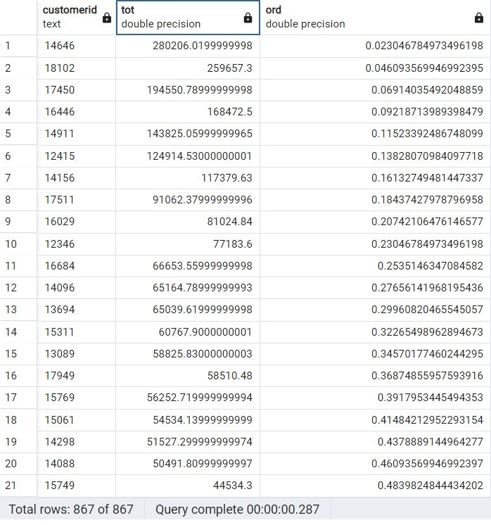

2nd query:

Then we will check the frequency of the customers purchases in dates to the to the customer total orders in dates to see whether the customer is still owned or need to be retained, the following query showing this point:

SELECT customerid, invoiceno,CAST(invoicedate as date), FIRST_VALUE(CAST(invoicedate as date)) OVER(PARTITION BY customerid ORDER BY CAST(invoicedate as date) DESC)

FROM online_retail

GROUP BY customerid, invoiceno, invoicedate;

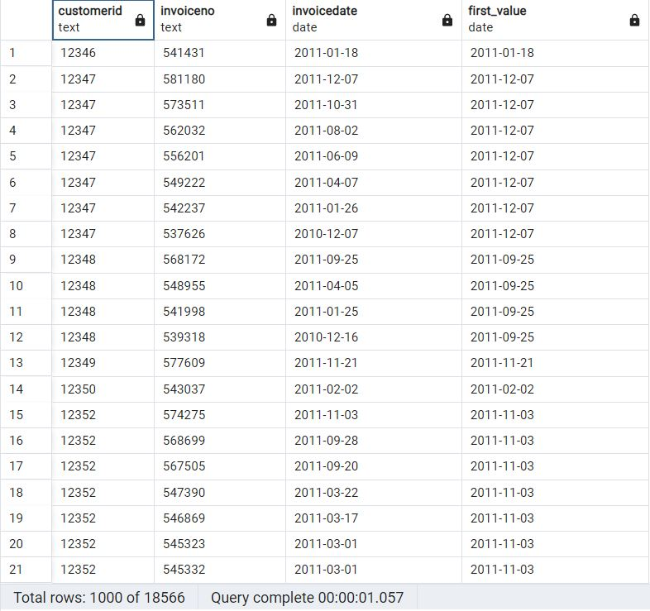

3rd query:

Then we will check the most selling item for each customer in order to retain those customers from a point of view that satisfying the customer needs to have an option to run an effective campaign targeting those customers to make the most profit on long running and reduce the cost in general as far as we can and we can check that through the following query:

SELECT customerid, stockcode, description, COUNT(stockcode), DENSE_RANK() OVER(PARTITION BY customerid ORDER BY COUNT(stockcode) DESC)

FROM online_retail

GROUP BY customerid, stockcode, description;

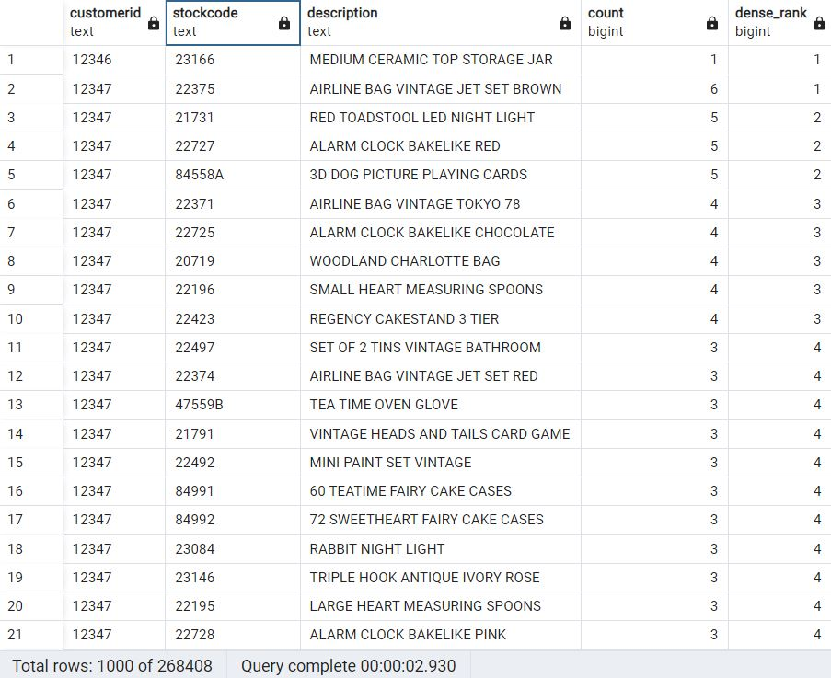

4th query:

In order to enhance the campaign offers we need to check the quantity of each item that the customer frequently buys and this is explored in the following query:

SELECT customerid, country, stockcode, description, COUNT(quantity),

DENSE_RANK() OVER(PARTITION BY customerid ORDER BY COUNT(quantity) DESC)

FROM online_retail

GROUP BY customerid, country, stockcode, description;

Note that there is a difference in the no. of output rows:

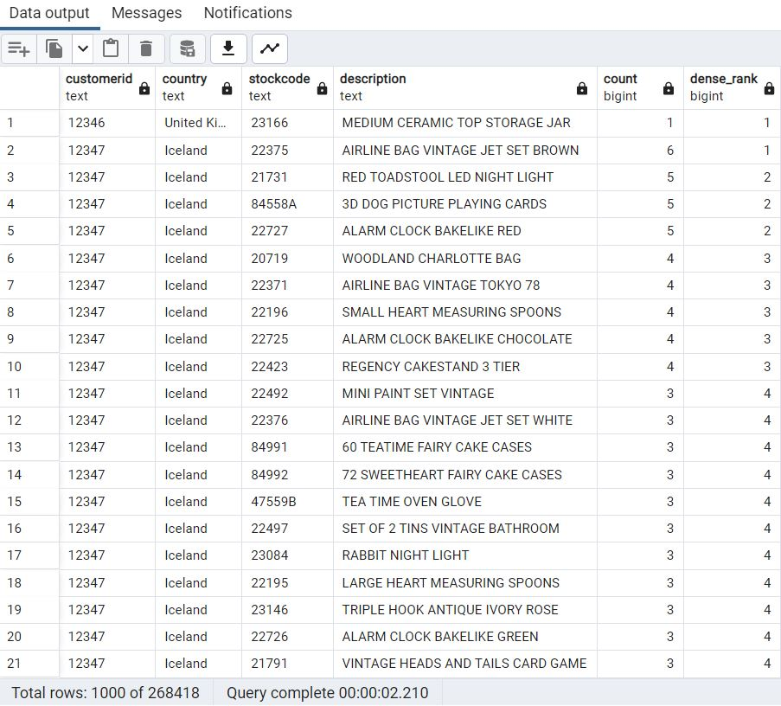

5th query:

Now let’s check the most important items regarding our e-commerce business in each country, the following query show the most selling 5 items in each country and this will help the Market Director to improve the performance of our company:

WITH most_prod(country, stockcode, description, coun, most_selling) AS (

SELECT country, stockcode, description, COUNT(stockcode) AS coun,

DENSE_RANK() OVER(PARTITION BY country ORDER BY COUNT(stockcode) DESC) AS most_selling

FROM online_retail

GROUP BY country, stockcode, description

)

SELECT country, stockcode, description, coun, most_selling

FROM most_prod

WHERE most_selling <=5;

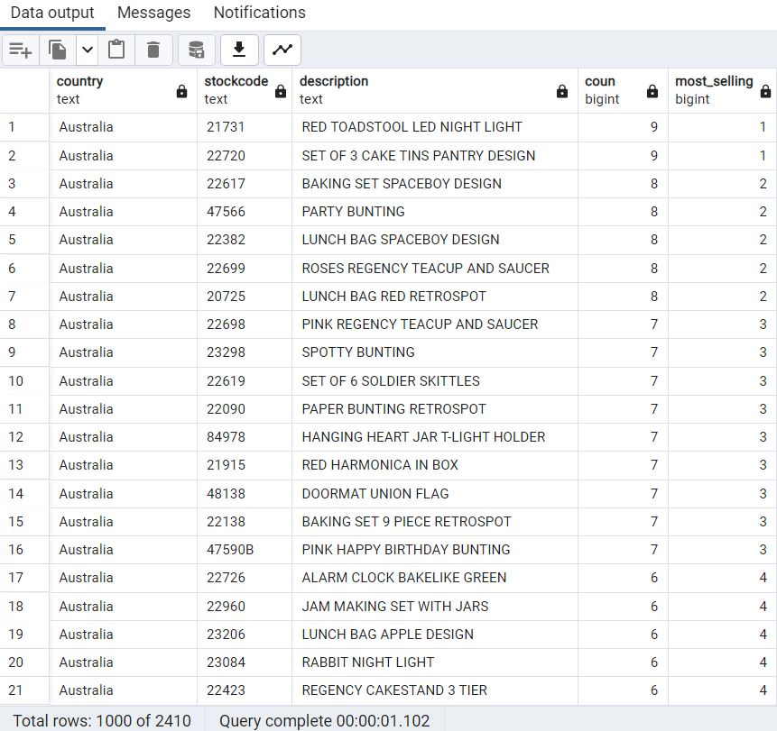

6th query:

Finally, we are going to check the most profitable five items in each country based on the sum of income as per this insight will manage to increase the profit in general for each region and this is shown in the following query:

WITH max_profit( country, stockcode, description, total, mx) AS (

SELECT country, stockcode, description, SUM(total_price) AS total,

DENSE_RANK() OVER(PARTITION BY country ORDER BY SUM(total_price) DESC) AS mx

FROM online_retail

GROUP BY country, stockcode, description)

SELECT country, stockcode, description, total, mx

FROM max_profit

WHERE mx <= 5;

